hw2

Follow directions below:

- Create an account with Coding Bat

(using your personal email)

- Complete the coding challenges below

- Upload screenshots of your results (the *entire* screen!!)

***Coding Bat: Python***

Complete the coding challenges listed at the links below on the CodingBat website. Log in and save your progress

Challenge 1:

List 1 > first_last6

([link](https://codingbat.com/prob/p181624))

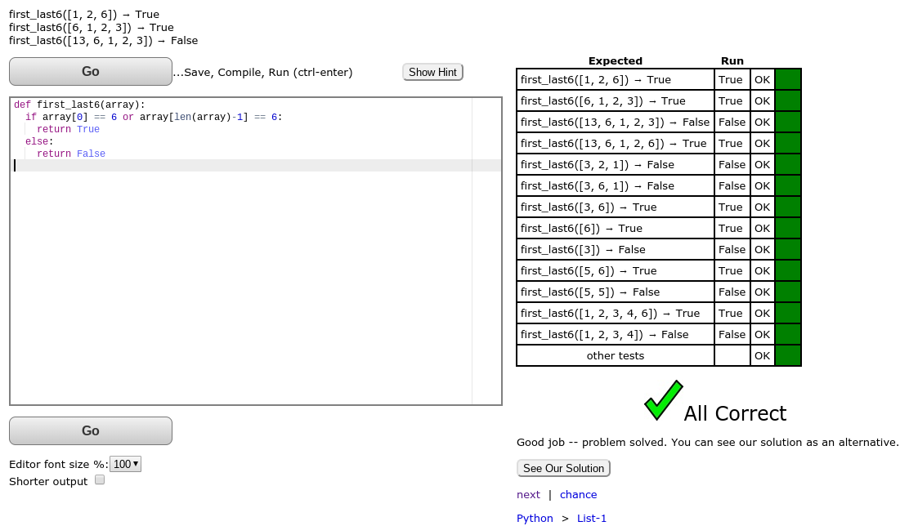

Challenge 2:

Link 1 > same_first_last

([link](https://codingbat.com/prob/p179078))

